**Math 120  
8.2 Arithmetic Sequences**

# **Objectives:**

1. Find the common difference for an arithmetic sequence.
2. Write terms of an arithmetic sequence.
3. Use the formula for the general term of an arithmetic sequence.
4. Use the formula for the sum of the first *n* terms of an arithmetic sequence.

# **Topic #1: Arithmetic Sequences**

A sequence is a string of numbers with some pattern or rule to get from one term to the next. Consider the sequence:

$14, 17, 20, 23, …$

The pattern suggests to “add 3” to get to the next term.

Using the pattern, here are the first $10$ terms:

$$14, 17, 20, 23,$$

Since the change from one term to the next is ________________

(here, the *absolute* change is $3$ more from one term to the next), the sequence is **__________________**

The constant absolute change is called the common difference, $d$ and the graph of the first $10$ terms in the sequence shows the pattern is “linear”. Notice the __________________________is the common difference.

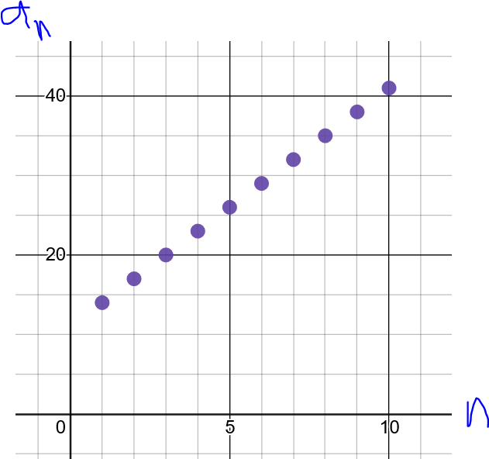

In this example, the first term is $a_{1}=14$ and the common difference is $d=3$. We can build the sequence directly from the first term by adding 3 and repeat the process for as many terms as desired.

*Example #1* – Write the First Six Terms of the Arithmetic Sequence

a) Given: $a_{1}=-9\text{ and }d=8$

The first term is $-9$, add $8$ to get from one term to the next:

Notice that any term minus the previous term is the common difference $d=8$

b) Given: $a_{1}=15\text{ and }d=-4$

The first term is $15$, subtract $4$ to get from one term to the next:

Notice that any term minus the previous term is the common difference $d=-4$

*General Term of an Arithmetic Sequence*

To find the $nth$ term of an arithmetic sequence, we can think about point-slope. The first term is the ordered pair $(1,a_{1})$ and the $nth$ term is the ordered pair $(n, a_{n})$. The common difference $d$ is the slope of the sequence.

Using point slope:

Consider the arithmetic sequence:

$$14, 17, 20, 23, …$$

The general term for the sequence is:

We can find any term along the sequence, for example when $n=100$:

*Example #2* – Write the General Term and the 50th Term of the Arithmetic Sequence

a) Given: $a_{1}=8 \text{and }d=2$

Using the general term formula:

When $n=50$,

b) Given: The sequence starts with the terms

$$-4, 2, 8, 14$$

The first term is $-4$ and subtracting any term from its previous term gives the common difference

Using the general term formula:

When $n=50$,

c) Given: The sequence starts with the terms

$$20, 16, 12, 8$$

The first term is $20$ and subtracting any term from its previous term gives the common difference

Using the general term formula:

When $n=50$,

# **Topic #2: Arithmetic Series**

A series is the sum of $n$ terms of a sequence.

$$S_{n}=a_{1}+ a_{2}+a_{3}+…+ a_{n-1}+ a_{n}$$

The properties of arithmetic sequences make it possible to find the sum of an arithmetic **________________** quickly.

Consider the first ten terms of the arithmetic sequence:

$$14, 17, 20, 23, 26, 29, 32, 35, 38, 41$$

As a series, the terms are added together:

$$S_{10}=14+17+ 20+ 23+ 26+ 29+ 32+ 35+ 38+ 41$$

Although it would not be too difficult to add the terms as above, we can speed up the process:

*Example #1* – Find the Sum of the First Fifty Terms of the Arithmetic Sequence

a) Given: The sequence starts as $3, 12, 21, 30, …$

The first term is $a_{1}=3$, the common difference is $d=9$, and the number of terms is $n=50$. We just need the 50th term:

Apply the sum formula:

Note: We could write out the $50$ terms and add, but it would take longer!

b) Given: The sequence is the first fifty positive EVEN integers.

It might be helpful to write a few terms out:

The first term is $a_{1}=2$, the common difference is $d=2$, and the number of terms is $n=50$. We just need the 50th term:

Apply the sum formula:

# **Topic #3: Applications of Arithmetic Series**

*Example #1* – Applications of Arithmetic Series

A company offers a starting salary of $\$24,000$ yearly with raises of $\$1600$ per year thereafter.

a) What is the salary in year 15?

The starting salary is $a_{1}=24000$, the common difference is $d=1600$, and $n=15$.

b) Find the total salary over the 15-year period.

Using the results above:

*Example #2* – Applications of Arithmetic Series

A concert hall has 10 seats in the first row, 14 seats in the second row, 18 in the third, and so on.

a) Suppose the concert hall has $30$ rows and the pattern described above holds. How many seats are in the 30th row?

The sequence is:

The first term is $a_{1}=10$, the common difference $d=$ and $n=$

b) How many seats are there in the concert hall?

Using the results above: